East Kilbride Old Parish Church

Looking Back: Our Response in Challenging Times

1: March 2020 - March 2021: What’s New at the Old Parish?

March 2021 marked the anniversary of the first Lockdown.
What a year it’s been for us all, personally, socially, or professionally. I hope you’ll agree that, rather than just moan, with our Minister, Rev. Anne Paton and Session Clerk, Alistair Walker at the helm, the Old Parish rose to the challenge of keeping our church together during ‘unprecedented times’.

It’s not all about the internet…
We couldn’t be together physically, so most solutions were digital, but we always had an eye on those who didn’t have internet, and introduced new non-digital ways of keeping in touch:
- For the first time, we printed the EKO through the summer to keep you up to date.
- We send weekly news to the ‘EK News’ Churches Column detailing activities and contacts. (Always the longest piece there!)
- The Minister writes a separate Reflection, printed next to that from St. Bride’s.
- We remotely monitor messages to our Church Office number and email daily, so we can respond quickly.
- We set up Helping Hands, 26 volunteers who delivered the EKO, prescriptions, and shopping, kept in phone contact with the isolated, and provided other help as requested – for the congregation and the community.
- Where we knew of someone on their own at Christmas, or needing a ‘lift’, we delivered 126 gift bags to bring some cheer.
- We record Sunday Services in formats to suit those without internet: USB sticks (for suitable TVs), DVDs, and in audio: Dial-a-Service, and CDs.
- We give guidance on how to join online meetings from a landline.
- Iain Shaw devised Village Treasure Hunts for families to get exercise, have fun and learn about Jesus while safe in their bubbles, yet taking part in an activity others were doing.

Embracing all things digital
Our biggest leap began somewhat in the dark… in March 2020 emails started: “Does anyone know how to…?”

Anne and Alistair learned quickly how to record short video messages to the congregation, which we posted on our church website and newly-launched Facebook page (excellent timing!).

Two weeks into Lockdown was Holy Week, but we couldn’t go to church… How could we not have services at Easter?
I tried making a mock-up video to get an idea, but could see that making even just one Palm Sunday service was going to be a big job, and there would be a week’s worth of Reflections and services to put together too. Not to mention doing it on a weekly basis!

Austin Hepburn came to the rescue, and has continued to work his magic since. What a star! His team helped as best they could, adding photographs for hymns, feeding back, getting Anne’s ‘at home’ recordings to him, finding readers. When he wasn’t in his creative ‘studio’, Austin would head out to the church or town to take more photos and video footage eg walking in and out of the church, to make it feel like you were really there. (I think it worked!)

He set up an online site where the team could share resources. We learned to upload the completed video and audio files to Youtube, our website, and Facebook (all new skills we had to learn).

By Easter Sunday, we had become almost-pros! Later we added in live-streamed services (our own and the Moderator’s); Christingle; the Nativity play; Communion - all being ‘firsts’ in their own right. Our own congregation recorded Bible reading videos and later their national and international ‘cousins’ joined in, increasing our sense of a church ‘family’.

Could we take it any further? Yes, we had been using old audio recordings of our choir, but EKO Editor, David Kent (formerly in Music Technology) introduced a fresher sound using his digital equipment. He compiled separate recordings of individuals (Colin and Richard Thomas, Elspeth Shearer, Hazel Brown and Christine Tweedie) to make a choir. Then at Christmas, he recorded Zoom video of each singing, and clever editing tricks made it look as if they were all singing together in church. Some of you expressed concern but be assured, they were all safely separate!

Iain Shaw, our Children, Youth & Families Worker, with a range of helpers, developed online children’s activities:
Zoom Sunday School/Messy Church; FLING; Online Holiday Club; Stories with Santa; Family Quizzes. As well as learning about the Bible, these have contributed to both the children’s, and parents’, wellbeing. The number of children/families ‘attending’ has gone up, some of whom are new to the church.

Normal activity groups had closed and our website’s ‘What’s On Calendar’ was empty, so the website Home page was restructured early on. We:
> sited the Sunday Service video and ‘news alert’ at the top of the Home page.
> deleted the empty ‘Calendar’ and ‘Notices’ sections.
> replaced them with the ‘blue stripe’ pages:

- ‘Our Response in Challenging Times’
which explains our new developments: the online Sunday services; Watch-a-Service, Dial-a-Service, DVD and USB formats; Zoom Online Sunday School and Coffee Mornings; our Facebook page; and the Helping Hands volunteers.
Here you will also find guidance if you are ‘New to Zoom’. (In addition, personal help over the phone is given if needed by Alistair Walker and Iain Shaw).
- ‘Other Special Notices’
covering general announcements, and prayers from the Prayer Group and Church of Scotland.
- ‘The Lighter Side’
containing uplifting items such as photos, poems, music, humour, many sent in by readers.

Zoom video meetings not mentioned above include: ‘Teas and Coffees’ (after-service chat, providing your own cuppa at home), Congregational Quiz, Kirk Session, smaller meetings, and Lent Bible Studies.

Thinking back to those March ‘20 emails, I smiled, remembering one asking: “Do you know how to make video calls to lots of people?” How we have progressed!

Since March 2020, we have shown ourselves to be a dynamic, forward-looking church, populated by a membership who either have skills, or are willing to learn them in the service of our church, and who are prepared to give a real commitment of time and effort. They reap the reward of knowing they are providing a much-needed service to our congregation in these challenging times, and they are helping to keep our church family together.

But it’s not just about Zoom, websites, and social media, is it?
There are lots of you out there, elders and non-elders alike, who are quietly getting on with phoning each other to have a chat and see how things are going, dropping a note through the door, saying hello as you pass the garden gate…. (all safely distanced). Your efforts are every bit as needed and appreciated. Keep it up! We all need to pull together in these ‘unprecedented times”!

CB March 2021

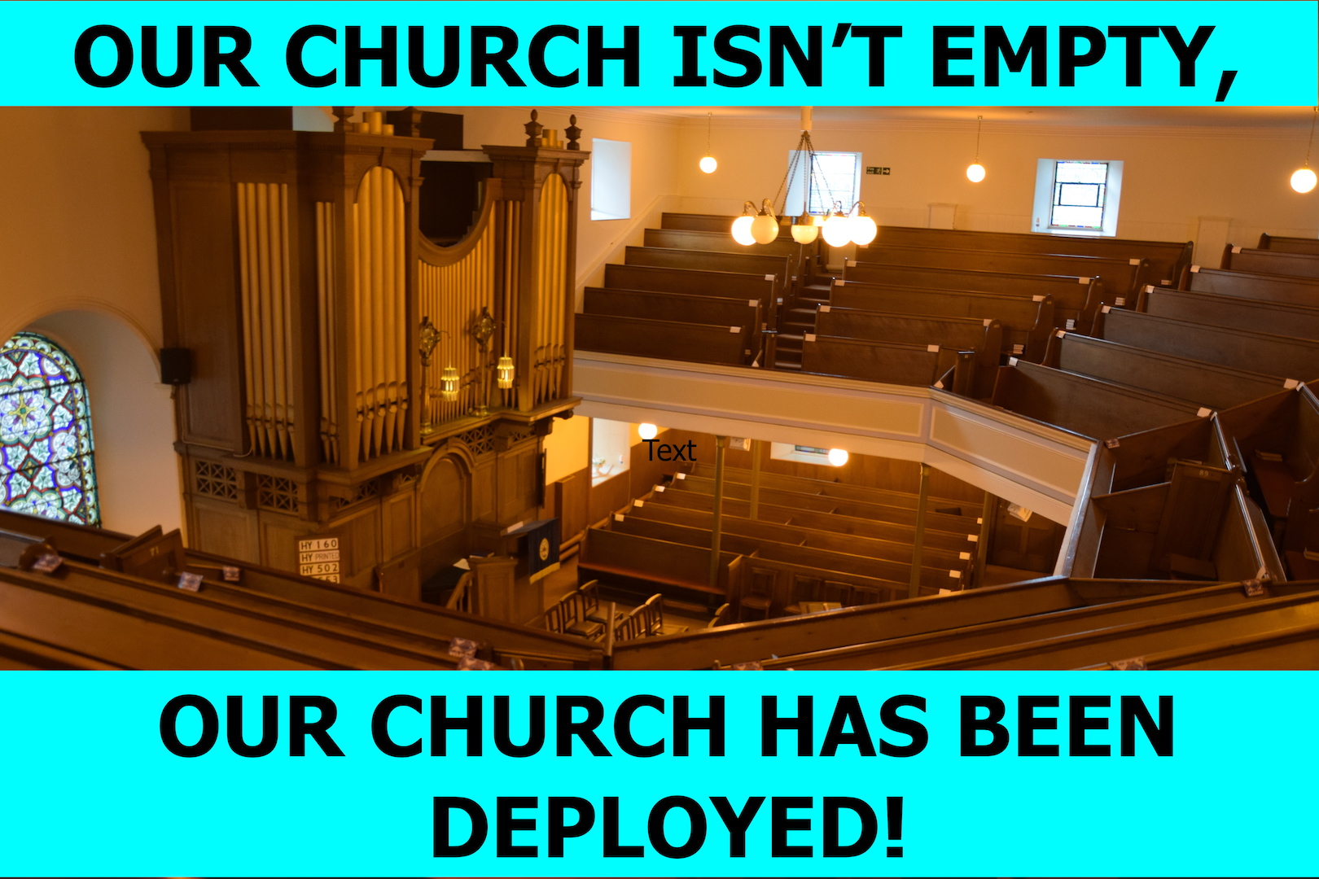
2. April 2021: Getting the Old Parish Church and Glebe St Hall ready for live services – making it safe for you to return to church

In March 2021’s EKO magazine, I detailed all the new-style work we have been doing in the church over the last year due to the pandemic. I say all the work, but I realised later that I had missed something very important out, something which we have been conscious of over Holy Week especially, and that is getting the Old Parish and Glebe St Hall ready for live services – not only making it safe for you to return to church, but also giving you the confidence to do so.

We now follow official guidance on enhanced church cleaning, administration procedures and ‘people management’ to ensure social distancing:

- Face masks and new cleaning materials, including hand-sanitising stations and sprays, have had to be ordered and made available

- Track and trace details have to be taken, forms completed and details checked on entry

- ‘Socially distanced’ seats (shown by a ‘green tick’) are allocated; the gallery is taped off. Elders/stewards direct the ‘traffic’ safely in and out of the church (or hall)

In addition to this work, we have our new technology to prepare: the cameras and sound for the live broadcast and ‘feed’ to Glebe Street Hall (overflow seats) need to be set up, checked and operated. Calls are made to the hall to check the broadcast stream is getting through. Problems are solved…

When the service begins, the congregation in the church can settle down in the familiar pews among kent faces (2metres apart!), knowing everything has been done to make them feel safe.

As they enjoy listening to Anne’s sermon, reflections and prayers, (sadly, they are not yet allowed to sing), they can rest their eyes on the warm wood tones of the pulpit and altar, and see the light playing on the colours in the stained glass windows as they listen to the Word of God…

Thanks to all the duty team elders and other volunteers, in both the Session Clerk’s team and Austin Hepburn’s ‘audio-visual’ team. They all did their bit to “let us build a house / Where love can dwell / And all can safely live……All are welcome in this place! “

CB April 2021

