s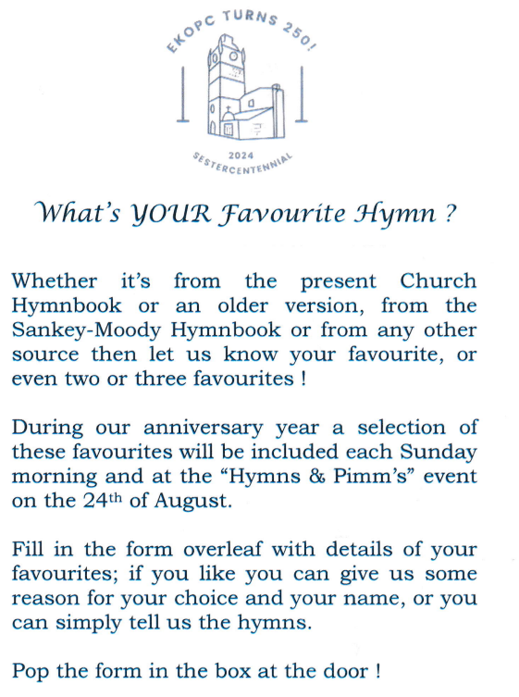
CH4 Hymn Number, Hymn Name or Opening Line
Also if you like to tell us about your choice
My Favourite Hymns are:
- _________________________________________

- _________________________________________

- ________________________________________

My Name (Optional

________________________________________

